Edition: 7

Date: 16/07/2025

INTRODUCTION

Welcome back everyone!

In this edition, I shall be speaking about book 2 of the “Insignitis” series, and my writing process. However, I shall be including a book suggestion.

Once again, I shall mention the cover designer. Joshua Griffin designed the cover for book 1 – Insignitis: Destiny. I shall be hiring him again for following books. I encourage everyone to view his work using the link below.

His website is: [www.joshuagriffinart.com](http://www.joshuagriffinart.com)

# PROGRESS OF BOOK 2

As stated in a previous edition, I began writing book 2 in October 2024. Usually I write frequently, but daily life does tend to become busy. My daughter is entering primary 1 in August of this year. I believe that’s kindergarten in the U.S.

I have been trying to write whenever I have spare time. In the last edition, I stated I had written 16 chapters. But since then that has increased to 36 chapters.

However, I do know book 2 will be longer than book 1. Book 1 has 49 chapters, and an epilogue. But my chapters are usually under 20 pages. The average is 11 pages.

I have predicted that book 2 may have 60 chapters, and an epilogue. Using these numbers, I have written 59% of the first draft.

I shall mention the new tropes that shall be in book 2 again:

* Family Feud
* Reluctant Hero
* Cassandra Truth (Hidden Truth)
* Magical Artefacts
* The Quest
* Medieval Settings
* Queer Romance

Like book 1, it is Slow Burn, but has many situations full of action, which is descriptive, so it’s not stoic.

It is also heavily based on Celtic mythology, but I have created my own mythical creatures, myths, and legends. Also, I like to include less-known mythical creatures in my novels.

# MY WRITING PROCESS

The manner in which I write is termed as pantser. It basically means I write whatever is in my head. However, a con of this is that it results in more editing. The other type is termed as outliner, but that style I struggle with.

I created this spider chart to provide a visual representation of my writing process.

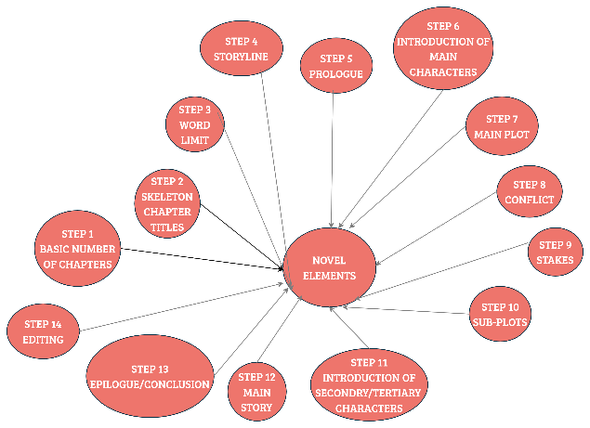

It has many steps because that is the way my brain functions. However, when it comes to editing, I find it stressful and dire. I struggle with perfectionism: one mistake bothers me. The outcome of this is that I read every chapter countless times. I also listen to them using text-to-speech.

Book 1 – Insignitis: Destiny, is available on **Amazon and Kindle Unlimited** (KU).

# BOOK SUGGESTION

One of my favourite authors is Donya Lynne. She is one of my “automatic buys”, so I have many of her novels.

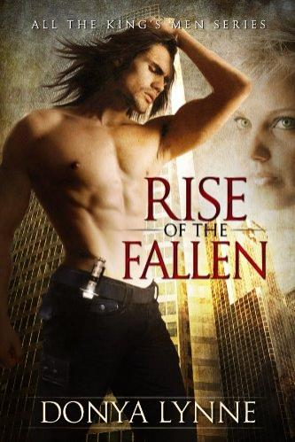There is a series titled: All The King’s Men, which comprises of 10 books, with one novella. It’s fantasy with a lot of spice. It involves vampires, but in modern day. They aren’t like “Dracula” or even the “Cullens” from Twilight. They are warriors that have many different traits. Book 1 of that series is: Rise of the Fallen.

# FRIENDLY GOODBYE

It has been fun writing this edition, and I hope my readers, writers, and authors continue enjoying every story they read or write.

Until next time, keep reading and creating. Please feel free to contact me on my social media platforms.